Swans in History

Inseparable from the history, culture, literature, heraldry and mythology of the
human species are those graceful inhabitants of our lakes, the Swans (Cygnus).
These amazing birds are not just bigger geese or ducks (their close relatives),
but emblematic creatures, metaphors, projections of anthropomorphic ideals,
images of aesthetics, paragons of light and beauty. Like the Albatross, swans
mate for life and have become a popular symbol of love and fidelity, reflected
in our folklore, fairytales (the Ugly Duckling, Den grimme ælling by Hans
Christian Andersen) and even in Opera, including Wagner’s Lohengrin and Parsifal.

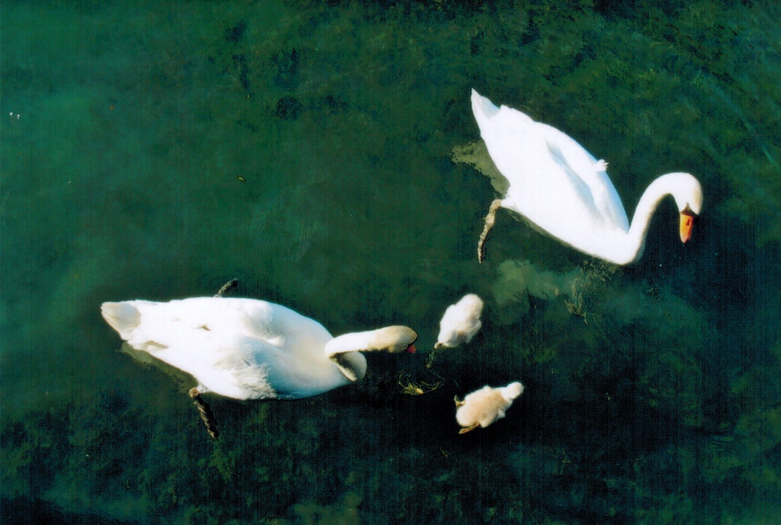
In Greek mythology the swan was consecrated to Apollo and revered as a
symbol of harmony. In art he was a frequent companion of Aphrodite and
Artemis. In his fable The Swan Mistaken for a Goose, Aesop (620–564 BC)
introduces us to the beautiful concept of the “swan song” (κύκνειον ᾆσμα ), that
final statement of meaning, love of earthly life, completion: "The swan, who
had been caught by mistake instead of the goose, began to sing as a prelude to
its own demise. His voice was recognized and the song saved his life."

Aeschylus (525-455 BC) comes back to the legend in his play Agamemnon,
where Clytemnestra sarcastically compares the dead Cassandra to a swan who
has "sung her last final lament". In Phaedo, Plato (428/347 BC) records that
Socrates contended that whereas swans sing in early life, they never sing as
beautifully as just before they die. This metaphorical phrase makes us dream,
because -- although we know that swans really do not sing (they hoot, grunt and
hiss) and are hardly musical nightingales – swans anthropomorphically intone
that final song of parting from this world, an eschatological though apocryphal
allegory, which had already become proverbial in Greece by the 3rd century
BC, and captured the imagination of countless poets and sculptors.

The Romans were wont to copy almost everything Greek, and thus Ovidius (43
BC-18 AD) refers to the legend in The Story of Picus and Canens, where: "she
poured out her words of grief, tearfully, in faint tones, in harmony with sadness,
just as the swan sings once, in dying, its own funeral song." We also find
allusions to the swan song in Vergilius (70-19 BC). However, Plinius (AD 23 –
79), who died in the eruption of the Vesuvius, challenged the belief:
"observation shows that the story that the dying swan sings is false."
Alfred Lord Tennyson’s poem The Dying Swan evokes the haunting song:

“The wild swan’s death-hymn took the soul
of that waste place with joy
hidden in sorrow: at first to the ear
the warble was low, and full and clear;
But anon her awful jubilant voice,
with a music strange and manifold
flow’d forth on a carol free and bold;
as when a mighty people rejoice
with shawms, and with cymbals and harps of gold…”

Tennyson's poem inspired the ballet The Dying Swan, created in 1905 for Anna
Pavlova to the music of Camille Saint-Saëns Cygne from The Carnival of the
Animals. Mikhail Fokine choreographed the ballet solo depicting the last moments of a swan’s life. It was first performed at the Mariinsky Theatre in St. Petersburg and thereafter conquered the world. This was the hey-day of Marius Petipa, who choreographed classical ballets showcasing technical prowess. Fokine's Dying Swan introduced fluttering lines representing the wings of the swan, and departed from the purely virtuoso technical show, the ballet solo highlighting deep emotion and tranquil movement. One gets a frisson every time.

In the same vein, the Finnish composer Jean Sibelius infused his tone
poem The Swan of Tuonela (1895) with the same mystery and magic, where in a
sublime solo, a cor anglais plays the dying song. It is the second part of Opus
22 Lemminkäinen (four legends) from the epic Kalevala. Undoubtedly, one of
the most enduring Lieder cycles is Franz Schubert’s Schwanengesang (D957),
fourteen songs published posthumously in 1829, which are considered his
musical testament to the world, memorably performed and recorded by
generations of baritones including Dietrich Fischer-Dieskau. No painting can
be more romantic than Caspar David Friedrich’s pair of swans in reed (1820),
Schwäne im Schilf beim ersten Morgenrot ( museum, St. Petersburg).

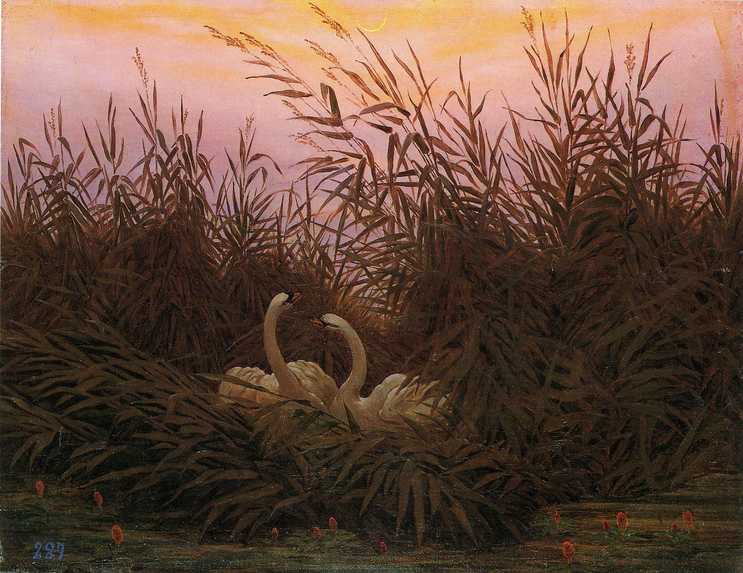

Another wonderful Greek myth is that of the seduction of beautiful Leda, Queen
of Sparta, by the god Zeus in the guise of a swan. This story was made tangible
in both Greek and Roman marbles, in a famous mosaic in Cyprus, and in
paintings, woodcuts and medallions, inter alia by Leonardo da Vinci,
Michelangelo, Benvenuto Cellini, Rubens, and Cézanne. Numerous writers
found inspiration in the myth, notably Rainer Maria Rilke (1875-1926) whose
poem Leda from the cycle Neue Gedichte (1907) I translate below:

“Als ihn der Gott in seiner Not betrat,
erschrak er fast, den Schwan so schön zu finden;
er ließ sich ganz verwirrt in ihn verschwinden.
Schon aber trug ihn sein Betrug zur Tat,
bevor er noch des unerprobten Seins
Gefühle prüfte. Und die Aufgetane
erkannte schon den Kommenden im Schwane
und wusste schon: er bat um Eins,
das sie, verwirrt in ihrem Widerstand,
nicht mehr verbergen konnte. Er kam nieder
und halsend durch die immer schwächre Hand
ließ sich der Gott in die Geliebte los.
Dann erst empfand er glücklich sein Gefieder
und wurde wirklich Schwan in ihrem Schoß.“

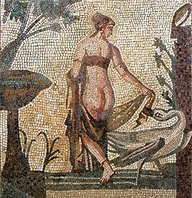

When driven by his need the god trod near
the noble swan, he marvelled at its grace,
and though perplexed, he vanished in its space,
already plotting an imposture dear,
not having tested how his feathered host
would feel. But she who opened as the prize
could recognize who came in swan’s disguise,
already sensing what he wanted most,
and while confused in her resistance, never
could she hide her own desire. Alighting
next to her, he wove his neck through ever
weaker hands and conquered her anon.
He revelled thus in plumage white, delighting
in her womb where truly he became the swan.

As Greek mythology would have it, Helen of Troy was conceived of the union
of Zeus and Leda. Since the metamorphosis of Zeus into a swan, literature has
drawn upon swans as symbols of transformation, and some psychologists
suggest that dreaming of a swan may indicate a special sensitivity, or a desire
for self-transformation.

In Japanese Ainu folklore, the swan was an angelic bird living in heaven. In
Hindu tradition it was the swan that lay the cosmic egg on the waters from
which Brahma sprang. Swans represent the perfect union, and the Hindu
goddess of learning, music and wisdom Saraswati has a swan as her
companion; the Raja Hansa or Royal Swan is her vehicle. The Sanskrit word
for swan being hansa, the Divine is called Parmahansa. Swans are thus revered
in Hinduism and compared to saintly persons whose chief characteristic is to be
in the world without getting attached to it.

The Irish legend of the Children of Lir is about a stepmother transforming her
children into swans for 900 years. In the legend The Wooing of Etain, the king
of the Sidhe (subterranean-dwelling) transforms himself and Etain, the most
beautiful woman in Ireland, into swans in order to escape from the Irish king
and his armies. Swans are also present in Irish literature in the poetry of W. B.
Yeats, The Wild Swans at Coole, which focuses on the mesmerising
characteristics of the swan.

In Nordic mythology, there are two swans that drink from the Well of Urd in the
realm of Asgård, home of the gods. According to the Prose Edda, the water of
this well is so pure that all things that touch it turn white, including swans and
all descended from them. Hans Hartvis Seedorff Pedersen’s poem The Nordic
Swans inspired the symbol of official Nordic co-operation, designed by the
Finnish artist Kyösti Varis for the Nordic Council in 1985. The swan symbol
with its eight quills represents the five Nordic countries Denmark, Finland,
Iceland, Norway and Sweden, and the three autonomous territories, the Faroe
Islands, Greenland and Åland. In 1989 the swan model became the Nordic
Ecolabel.

In Latin-American literature, the Nicaraguan poet Rubén Darío (1867–1916)
consecrated the swan as a symbol of artistic inspiration and drew attention to
the constancy of swan imagery in Western culture. His most famous poem in
this regard is Blasón (1896), in which the swan emerges as a symbol of
Modernismo, the poetic movement that dominated Ibero-American poetry from
the 1880s until the First World War, characterized by idealism, sensuality and
nobility.

In North-American Navajo tradition, the Great White Swan conjures
up the Four Winds, while the Great Spirit uses swans to carry out its will.
While European, American and Asian swans are mostly white, we are also
fascinated by black swans (Cygnus atratus), which have other symbolism.
Native to Australia and Tasmania, they were introduced in other regions of the
world, where they live not only in parks but also in the wild. Australian
aborigines saw the black swans as the wives of their All Father. Concerning
black swans, the Roman poet Juvenalis (60-133 AD) made a sarcastic reference
to a good woman as a "rare bird, as rare on earth as a black swan", wherefrom
the Latin phrase rara avis or rare bird originates. Surely an expression of misogyny, but interesting as a form of literary stereotyping.

Without a doubt, the most famous ballet on the repertoire is Pyotr Ilyich
Tchaikovsky’s Swan Lake (Лебед ное озе о), produced for the first time in 1877
at the Bolshoi Theater in Moscow. The story begins with Prince Siegfried’s
celebration of his 21st birthday and the social necessity that he choose a bride.
He does not fall in love with any of the pretty maidens at the Court, but escapes
to the woods and at a lake he is attracted by the beauty of a white swan, who is
none other than Princess Odette, transformed into a swan by an evil magician
Rothbart, and whose spell can only be broken through true love. Alas, when
Siegfried is about to liberate her, Rothbart produces Odile, a black swan, who so
confuses Siegfried, that he ends up choosing Odile instead of Odette. The
original story does not have a happy end. But many modern productions have
modified the final scene (without touching the glorious music) so that Rothbart
engages in a formidable duel with Siegfried and has his wings torn off,
whereupon Odette is freed from the curse. Such licentia poetica (Seneca) --
poetic licence – enriches both literature and music. Personally, I prefer it,
having enjoyed this romantic interpretation danced to perfection by the
Mariinsky Ballet of St. Petersburg.

A Gesamtkunstwerk (total work of art), a fusion of art forms, mythology,
literature, music, ballet and staging is worth striving for and can be achieved. Our world in all its wonderful diversity and splendour is in itself a Gesamtkunstwerk that must be enjoyed and preserved for future generations. Henceforth, let us attempt to capture the magic of the swan as a symbol of beauty, freedom, fidelity, light, air and water -- as an evocation of a multitude of feelings, impressions, nuances and yearnings of all humanity.

